ft(

� I,

YCH)u

**Telehealth Informed Consent**

, (name of patient) hereby consent to participate

**Community Health Center**

**In CoWfcy Co�i1ty, Inc.**

**Weslside Clinic - Winfield**

***Hetzltb Carefor Everyone***

in telehealth services with Community Health Center in Cowley County providers as part of my treatment. I understand telehealth is the practice of delivering clinical health care services via technology assisted media or other electronic means between a provider and a patient who are located in two different locations.

***I understand thefollowing with respect to telehealth:***

1. I understand I have the right to withdraw consent at any time without affecting my right to future care, services, or program benefits to which I would otherwise be entitled.

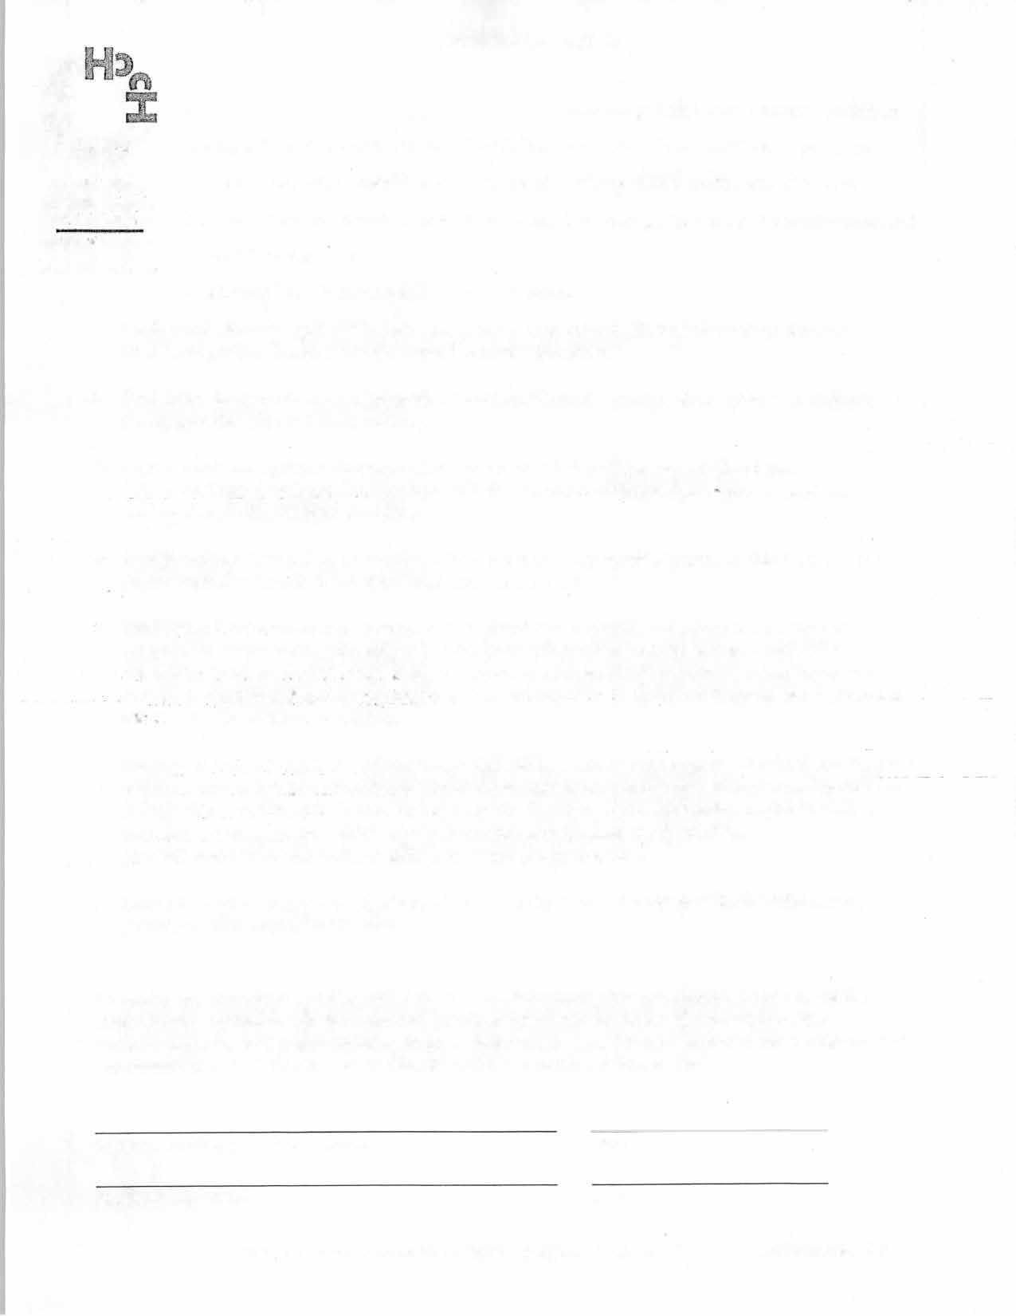

1. I understand in the event of a crisis/emergency situation where my safety or others' safety is in jeopardy, I or my provider will call 911 immediately.
2. I agree to only use electronic communication with my provider(s) during their scheduled work days/hours. I fm:ther understand my provider will not read communications from me nor respond to me outside of regularly scheduled work hours.
3. I understand messages will be replied to within 24 hours or on my provider's next scheduled day of work (in_the event of weekends, holidays and vacation, sick leave, etc.).
4. I under�tand there are risks and consequences associated with telehealth, including but not limited to, disruption oftransmission by technology failures, interruption and/or breaches of confidentiality by unauthorized persons, and/or limited ability to respond to emergencies. Ifthis occurs, end and restart the

,__________.session. If_technical difficulties-arise and �ervices is interrupted, try to reconnect. If unsuccessful, please call -------- ---

620-221-3350 to continue/re-schedule.

1. I understand.there will b"e no.recording ofany of the online sessions by either party. All information disclosed within _sessions and wri_tten_records pertaining to those sessions are confidential and may not be disclosed to anyone without written authorization, except where the disclosure is permitted and/or required by law (i.e. mandatory reporting of child, elder, or vulnerable adult abuse; danger to self or others; physical/mental/emotional health as an issue in a legal proceeding, etc.).
2. I agree not to share my provider(s)' electronic contact information with anyone without first obtaining permission from the provider to do so.

**By signing my name below, I indicate: I have read the information provided above. I understand the information contained in this form and any questions I have will be discussed with my provider. I understand the risks of communicating through electronic devices. I hereby authorize my provider(s) and Community Health Center in Cowley County staff to contact me electronically.**

Signature of client/parent/legal guardian Date

Signature of provider Date

Much of the information contained in the form was obtained from NASW. CHCC March 24, 2020